iMPROVING cOMMUNITIES FOR cHILDREN, yOUNG pEOPLE AND fAMILIES
York’s early help and prevention model
grants 2016/17
Proposals up to £5,000
Deadline for applications: Wednesday 30th November 4:00pm

Funding calendar:
Applications released 31st October
Deadline 30th November
Funding panel will meet 9th December
Decisions emailed out on 12th December
Start date of the projects January 2017
All projects to be completed by end of March 2018

york’s new early help and prevention arrangements
Local Are Teams (LAT) are a key part of York’s early help response to working with children, young people and families from pregnancy through to adulthood (the 0-19years (25 years for disability) agenda. A Local Area Team (LAT) is a multi-agency team covering one of three defined geographical areas of York. The purpose of the Local Area Team is:
- To prevent the escalation of needs which may require, if not address, statutory, complex and costly interventions at a later point.
- To reduce inequality of outcomes for our communities across York.
Local Area Teams are not just a set of council services. They are multi-agency and bring together all partners in a local area that exist in the lives of children, young people and families. This way Local Area Teams can bring together the full power of our communities to address need and build resilience.

Localities
This funding will be used to deliver positive outcomes for children, young people and families in the three areas and citywide. The map below shows the Local Area Teams across the city. Local Area Teams will have their office bases located at the three designated children’s centres of:
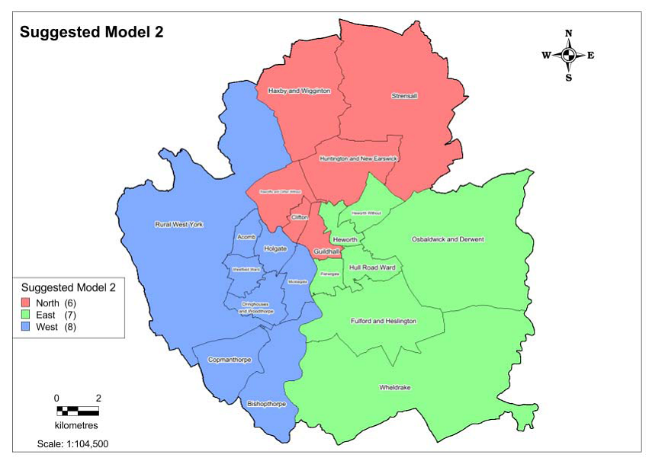
- Tang Hall
- Hob Moor
- Clifton

Officers will be based in these locations but will operate across the city either through supporting other practitioners or work directly with children, young people and families. Work will be delivered through these three building blocks:

Who can apply?
To qualify for funding, applicants may be voluntary and community, charity and non-profit organisations and must have policies and operating procedures in place appropriate for working with children and young people. These include the basic requirements of the Children Act, Health and Safety legislation and/or other standards relevant to their discipline such as Ofsted registration. Services will also be expected to register their organisation on the YorOK Service Directory (http://www.yor-ok.org.uk/). This registration includes a checklist that we will use as your self-declaration of having relevant and up to date policies in place.

desired Outcomes

This fund is focused on delivering the outcomes below. Our ultimate aim is for all our children and young people to have a chance to be safe, resilient and achieving. To be this, they need:
- Basic physical care – Somewhere suitable to live, clothing, food.
- Health – Living a healthy lifestyle, access to dental care, good mental health.
- Parenting / emotional – Loving and nurturing parenting that develops resilience, self-management and aspiration.
- Education and employment – A good quality education that equips a young person for life, good employment opportunities and career prospects.
- Positive social networks and communities – The wider environment should support, encourage and develop strong identities and high aspiration.
- Safety – A child’s basic needs to be safe and protected from harm should be in place.
- Responsibility and independence – Children and young people should be given the opportunity to become responsible and independent in their decision making as they grow.
- Increasing Capacity – enabling more children, young people and families to access provision
- Improving quality – of provision in early help

We want to hear from projects that can
We encourage bids that:
- Pilot – develop new ways of working
- Capacity building – supporting groups to get ready for the future
- Research and development – action research and evaluation and sharing of the practice
- Reduce inequality in groups
- Trial and demonstrate better outcomes
However we can not support bids that provide:
- Activities outside of York or that involve more than 10% of children who live outside the city boundaries.
- Activities which fall outside the age range of school age children (0 – 19 years (25years for disability)
- Activity providers who are not either signed up to Yor-OK (http://www.yor-ok.org.uk/) or do not have all necessary policy and procedure in place by 30th November. (See question 11)
- Continuation funding for current mainstream activities

Project information

Which area is your project in?
North
East
West
City wide

Description of the project:

3. Summary of how it will work:
Inputs
(resources e.g. worker wages, building rent etc.)
Activities
(what will actually happen e.g. worker assess an issue, interventions).
Outputs
(Indicators which contribute to demonstrating the outcomes e.g. attendance figures, performance)
Outcomes
(Identify the overarching outcomes – what would you see? How would the world be different?)

4. Who will benefit, how many, where etc. (This should be a more detailed description of how this project will address one or more of the issues below.)
- Basic physical care – Somewhere suitable to live, clothing, food.
- Health – Living a healthy lifestyle, access to dental care, good mental health.
- Parenting / emotional – Loving and nurturing parenting that develops resilience, self-management and aspiration.
- Education and employment – A good quality education that equips a young person for life, good employment opportunities and career prospects.
- Positive social networks and communities – The wider environment should support, encourage and develop strong identities and high aspiration.
- Safety – A child’s basic needs to be safe and protected from harm should be in place.
- Responsibility and independence – Children and young people should be given the opportunity to become responsible and independent in their decision making as they grow.
- Increasing Capacity – enabling more children, young people and families to access provision
- Improving quality – of provision in early help

5. Please describe your process/methods of engaging with children young people and families. This should show how disadvantaged children and young people, who would not otherwise be engaged in activities/opportunities, will get to know about your project.

6. Which agencies do you work in partnership with?

7. Financial requests and supporting contribution :
7a. Resources that partner group/s will provide and the value:
Description of resource | £
Totals

7b. Funding Costs Breakdown:
Provide a breakdown of funding required for the project/activity from the Local Area Team Grant.
Funding Breakdown | Grant £
Totals
Receipts will be requested for successful bids.
Include here all other funding resources received or currently bid for.
Other funding sources related to this project | Awaiting outcome | Funding Confirmed
Total

8. What will the cost per person be for your provission/services?
Please give comprehensive information about how the funding will be spent. Consider how many young people you expect to be working with and how long the project will last. You may be able to provide a cost per person on your project or show the capacity of your sessions over a period of time?
Total Funding requested = £
Number of young people / families benefitting =
Number of sessions =
Number of contact hours with each child/young person or family =
Length of the project = days or weeks

9. What will you provide to evidence that the project has been monitored/evaluated? This should demonstrate that the outcomes have been addressed.

10. Will the project be sustained in the future (list the benefits of the project going forward for example increased capacity,) or describe the exit strategy for the project.

11. Policy Checklist:
Policy/Procedure available and in force | Status
Disclosure and Barring Service Checks
Child Protection / Safeguarding
Insurance
Health & Safety
First Aid Arrangements
Accident and Incident Reporting
Consent forms
Equal Opportunities Policy
Behaviour policy
Staff ratio policy
Financial management processes (bank account etc)
Governance structures (Trustees, management committee, etc)
Recording, Monitoring & Evaluation
Compliments, Complaints, Whistle blowing systems
Data Protection/ Confidentiality/ Information sharing

12. Key Personnel and contact details

Organisation name
Contact person
Job title
Address
Office number
Mobile number
Email address

standard conditions

- We will require evidence of how the funding was spent. This can be provided in a variety of ways such as photos, feedback forms, alongside receipts for equipment.

- Organisations will need to provide evidence demonstrating the benefits of the scheme.

3. Any under spend following the completion of the activity shall be returned.

Upon approval of your funding bid a funding agreement will be signed by both City of York Council and the funding recipient. This will include an agreed process or monitoring and evaluation and a time frame for doing this.
Regrettably we can not guarantee feedback on all applications. Decisions are made by a cross-service panel from City of York Council, all of whom will be working with children and young people.
Please return completed forms by email to: youthandcommdevteam@york.gov.uk

Deadline for applications: Wednesday 30th November 4:00pm

For enquiries please contact:
The Youth and Community Development Team
City of York Council, Moor Lane Youth Centre, Wains Road, Dringhouses, York, YO24 2TX

youthandcommdevteam@york.gov.uk

